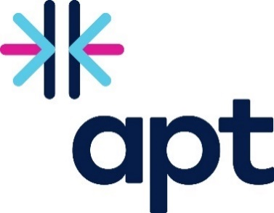
Apt Awards 2023

Nomination Form

Please return the complete form to apt@susescotland.scot by Tuesday 28th February.

Criteria: all nominees should have participated with Apt PSP between March 2022 and March 2023. There are 5 categories and you can put forward a nominee in as many categories as you wish. You can nominate an individual or organisation you have either worked with or are aware of their positive contributions and progress via Apt news (bulletins, social media, website). You can also nominate your own organisation or a colleague in the relevant categories.
Who is completing this form?
Name and Organisation:

Apt Employer of the Year
This employer will have demonstrated outstanding commitment to diversity and are a leader in their industry who are dedicated to integrating diversity, equality and inclusive practices in their organisation, specifically in relation to reducing the Disability Employment Gap.

Name of Organisation:

Reason for nomination:

Apt Employer Champions
Organisations who have demonstrated progress in becoming a diverse workplace. You can nominate more than one organisation.

Name of Organisation:

Reason for nomination:

Diversity Champion
An individual who has led the way in their organisation. This can be an individual working for an Apt employer, partner, or workstream member.

Name of Individual:

Reason for nomination:

Provider of the Year
An Apt partner who has made a meaningful contribution to progressing the PSP and working towards a Centre of Excellence.

Name of Organisation:

Reason for nomination:

Outstanding Contributions to Apt
An individual who has made significant contributions within the PSP.

Name of Individual:

Reason for nomination:

Selection
A committee has been created which includes selected SUSE staff and PSP Steering Group members. The committee will review all nominations and make the final decision on award winners.

Winners will be announced at the SUSE Annual Conference on Tuesday 16th May and awards will be presented at the conference. Individuals and organisations will be informed that they have been nominated and selected for an Apt Award in advance and will receive one complimentary ticket per winner.

